

**Project Closure Report**

Charity Second-hand Online Store

**Revised records**

|  |  |  |  |
| --- | --- | --- | --- |
| **Update Date** | **Version** | **Description** | **Name** |
| 28th May 2020 | V1.0 | Initial version | Guozhi Yin |
| 02th June 2020 | V1.1 | Update details | Cong Shang |
| 03th June 2020 | V1.2 | Final version | Guozhi Yin |
|  |  |  |  |

Table of Contents

1 Executive Summary 3

2 Project Background 4

3 Project Purpose 5

4 Project Management Evaluation 6

4.1 Scope Management 6

4.2 Schedule Management 9

4.3 Quality Management 11

4.4 Communication Management 17

4.5 Risk Management 18

4.6 Human Resource Management 21

4.7 Data Management 22

4.8 Resource Management 22

5 Lessons Learned 23

6 Project Delivery 27

7 Closeout evaluation 29

8 Recommendations for future projects 31

# Executive Summary

After three months of project effort, the project team successfully completed the go-live of the project in the face of external pressure (such as COVID-19) and other project risks. The project team has two members (Guozhi Yin, Cong Shang). Our client is Zoe Liu. Our advisor is Ian Hunter. In this project, we have the opportunity to connect with local businesses through technical means and successfully complete a commercial software product practice.

The project team used the prototyping methodology to manage the life cycle of the software product so that the client can intuitively understand the functional design of the product and reduce the deviation in the requirement communication. The project team managed the entire project process through the project management software ‘Microsoft Project’. From the beginning of the planning phase, a clear set of objectives for each phase to be output, as well as the tasks and responsibilities of each member. The overall execution of the project was carried out according to the project plan. Due to some reasons, some milestones were delayed, which did not affect the delivery time of the project. Thanks to advisor Ian Hunter for his participation and guidance from the beginning to the end of the project, the project team successfully completed all five milestones.

The project team has completed all the process of the project and successfully delivered all the materials to the client and satisfied all the client’s needs. During the cooperation with the advisor and the client, project members got familiar with some knowledge of business cooperation. Moreover, after doing a lot of research, we also made a lot of improvements in our technology. I would like to express my gratitude for this project opportunity, which provides a very good experience for us to engage in other projects after graduation.

# Project Background

The second-hand market in New Zealand is an important shopping option for locals, not only because of its low price, but also because of its high quality. Especially high -quality second-hand goods, is the target of residents to snap up. Many charities operate second-hand shops in New Zealand, but it is worth noting that the information construction of all second-hand shops is relatively backward, and there are basically no online shops. Customers have to go to the store to see if there are items they like, so they can't give consumers a better shopping experience. Based on this background, the project team planned to develop a charity second-hand online store, so we conducted demand research and project cooperation negotiations.

Our first client is Zoe Liu who works as an accountant at the Church of Salvation Army in Lower Hutt. The church has a national second-hand store called the Salvation Army Family Store, which collects items donated by residents (clothes, toys, kitchen supplies, etc.). It provides stores for residents who like second-hand goods, and the incomes will be used to run churches and help people in difficult areas. Thus, by creating a charitable second-hand online store, there is an opportunity to increase revenue by adding value to higher-value donated items.

Currently the main online auction platform in New Zealand is Trade me, but it is a commercial platform and not suitable for charities. Therefore, the establishment of a charity second-hand online website can better attract the involvement of caring people and better serve the community. The project can be used by all charities. In terms of market prospects, there is an opportunity to become a national charity website for the use of charity second-hand shops across the country.

# Project Purpose

We plan to set up an online auction store for second-hand charity shops. This will allow residents to browse high-quality second-hand goods online, and if the auction is successful, customers will be able to make an appointment online to pick up the goods and pay at the store to complete the transaction. This will significantly increase the number of participants, increase transaction efficiency and increase turnover and revenue. The reason why we chose the auction method is that we investigated the second-hand shop and found that the second-hand shop is operating the auction mode. Second, the inventory of second-hand stores is special. There is only one item for each item. Therefore, if all the items are uploaded online, they need to be removed from the shelves once they are sold in the store. Thirdly, high-quality second-hand goods are suitable for auction, so that charity second-hand shops can get better transaction income, so as to help more people in need and enhance community services.

# Project Management Evaluation

## Scope Management

During the initial phase of the project, the project team conducted several surveys on the requirements and discussed with the client the problems and solutions of each requirement. After that, the project team wrote the project requirements document and confirmed these requirements with the client. We defined the scope of the project at this stage based on the requirements determined with the client. The list of function points of this project is shown in the figure below.

|  |  |  |  |  |
| --- | --- | --- | --- | --- |
| **No.** | **Model** | **Model** | **Functional point** | **Description** |
| 1.1 | User | Goods display | Main page goods display | Display the 12 goods which are the closest to the close time |
| 1.2 | Goods display by category | Show the goods by category. In this system, it splits into 5 categories, such as toy, kitchen, tools, decoration and clothes. |
| 1.3 | View the detail of the goods. | Display the product details in the web page which includes the title ,initial price, current price, picture, the description of goods , close date and bid history |
| 2.1 | User management | Login | User input user name and password to login to the website. If a user did not login, the user only can browse the goods， but do not allow to bid. |
| 2.2 | Logout | User can logout at any time, if users do not do anything than 30 minutes. The system will logout automatically |
| 2.3 | Register | User can register an account by inputting some personal information |
| 2.4 | Password recover | User can find password by personal mobile number and email information |
| 2.5 | View the personal information | Show the user's personal information in the page. |
| 2.6 | Edit the personal information | User can update their personal information, but the user name could not be updated. |
| 3.1 | Auction | Auction | The bids price must higher than the current price. The auction time must be earlier than the close date. |
| 3.2 | ~~Donation~~ | ~~This function has been deleted.~~ |
| 4.1 | Order management | View the order | After the user login , user can check their order which they win. |
| 4.2 | Make appointments | Booking for pick up |
| 5.1 | Cart | Add items into the cart | Put items into the cart so that can find them any time. |
| 5.2 | Cart list | Show the state of items which is in the user's cart. |
| 5.3 | Delete items from cart | Delete items from the cart |
| 6.1 | About us | About us | Show the introduction of the online store. |
| 7.1 | Contact us | Contact us | Shows the information of the shop. It includes address, website, contact phone number. |
| 8.1 | Admin | Goods management | Display product list | In the model, the system displays all of the goods in the system. |
| 8.2 | Add a new commodity | Administrator can add new goods for auction |
| 8.3 | Edit commodity | Administrator can modify goods information |
| 8.4 | Delete commodity | Administrator can set goods status |
| 9.1 | User management | Display user list | Display user's list |
| 9.2 | Change user's state | Enable or disable user's status |
| 9.3 | Change admin's state | Change admin's status |
| 10.1 | Order management | Display order list | Display order list |
| 10.2 | Change order status | When the user pick up, the admin change the order state to finish. |
| 11.1 | System | Generate orders | Generate orders | Create orders for the successful auction |

In the process of project scope management, according to the process of project management, we have done the following work in project scope management:

* At the early stage of the project, the project team made a preliminary survey on the scope of the project. Understand the client's basic requirements and make a project prototype for the requirements discussion.
* The scope of the project is clearly defined. Due to the fixed project cycle and limited human resources, in the early stage of the project, we made clear with the client what the project scope included and what it did not include, such as mobile terminal, online payment, location query and business promotion. The scope boundaries of the project were formally signed through discussions with the client and the project team.
* In order to prevent omissions and clarify responsibilities. We broke down the project. The project is broken down into minimal control units, known as work package. The decomposition orientation we adopted was the top-down analysis. First, the project milestones were determined and graded step by step. Finally, the responsible person and deliverables are defined for each work package. Due to a large number of work packages in this project, in order to better display and search, we recorded and made a number for each work package in the form of a list.
* Scope confirmation. We communicated with the client in real-time about the completed work and constantly confirmed with the client when deliverables are produced. Turn deliverables into the client’s confirmed deliverables and adjust the unsatisfactory content in time.
* Monitoring project scope. It is well known that project scope spread is one of the main causes of project failure. In order to prevent the change of project scope, we formulated the principle of project change at the early stage of the project. The principle is that when the scope of the project changes, the applicant needs to send a formal change request in a form. The project will assess the impact of the project and submit the evaluation results to the change control board (CCB). An application for a change in the scope of the project will be approved only if it has been approved at all times. After the changes are approved, the project team keeps a record, reallocates resources and tracks the changes. For this project, one project scope change requests occurred, it is that deleting the donation function.

## Schedule Management

Based on the scope of the project, the project team first identified the project milestones. In this project, the methodology we used is the prototyping method, whose main purpose is to better obtain the client’s needs and reduce differences. But we also took advantage of the waterfall model to identify project milestones. The project includes the proposal, system design, development, testing, and closure of five major milestones, as shown in the following.

|  |  |  |  |
| --- | --- | --- | --- |
| **Milestones** | **Planning Date** | **Actual Date** | Reason |
| Proposal | 20th March 2020 | 20th April 2020 | Communication and personnel issue. |
| System design | 30th March 2020 | 19th April 2020 | Document modification |
| Development | 14th May 2020 | 14th May 2020 |  |
| Testing | 26th May 2020 | 26th May 2020 |  |
| Handover | 29th May 2020 | 29th May 2020 |  |

We used the Project management software Microsoft Project to plan the progress management of the Project.

In the activity definition process, we take a step-by-step approach, identifying milestones first and then decomposing them. We will split the project as much as possible, but due to the existence of project uncertainties, the long-term work content of the project will be continuously decomposed, tracked and updated. We also defined project checkpoints to compare project performance.

In order to sort the work content, we refer to the resource calendar of the project to avoid conflicts with the meeting of the advisor and the client. In this project, although we did not draw Arrow Diagramming or Precedence Diagramming to sort of project activities, We used the project tools to order execution in the definition of the project activities and also to schedule the activities.

In the planning process of the project, we found that the time of the project would exceed the prescribed time range after sorting the activities and allocating resources to the activities. So we compressed the Critical Path of the project and performed some work in parallel. For example, in the development phase of the project, the project team began to prepare and write test plan and test case, and the client also began to prepare for the online environment. The compression of the critical path greatly shortens the project implementation cycle.

In the middle of the project, we compared the actual input of the project plan and found that the project was 2 days behind schedule. In order to ensure that the project can be delivered on time, we communicate with the client to reduce the workload of the project by reducing the scope of the project. We decided to delete the donation module and get the project back on track.

## Quality Management

In order to ensure the quality of the project, the project implemented a complete software testing process. First, in the project planning phase, project team also developed test plan and test case. The testing included integration testing, system testing and user acceptance testing. We used the method of black box testing. The client, Zoe Liu completed the user acceptance testing. After the project team finished the test, the corresponding test report was also written.

Integration Testing

【**Testing case statistics**】

|  |  |  |  |  |  |  |
| --- | --- | --- | --- | --- | --- | --- |
| Date | Total number of testing cases | The total number of cases found | Total number of cases resolved | Total number of cases with legacy issues | General Error rate (number of cases found/total number of cases) | Serious Error rate (number of cases found/total number of cases) |
| 15th May 2020 | 18 | 5 | 5 | 0 | 27% | 3% |

【**Issue category statistics**】

|  |  |  |  |  |  |  |  |  |
| --- | --- | --- | --- | --- | --- | --- | --- | --- |
| Requirement unfulfilled | Function failure | Data loss | Abnormal display | Abnormal performance | Poor user friendliness | The message is incorrect | The total number of issues | Number of remaining problems |
| 0 | 8 | 0 | 2 | 2 | 2 | 0 | 14 | 0 |

During the integration test, our test results are shown in the figure.

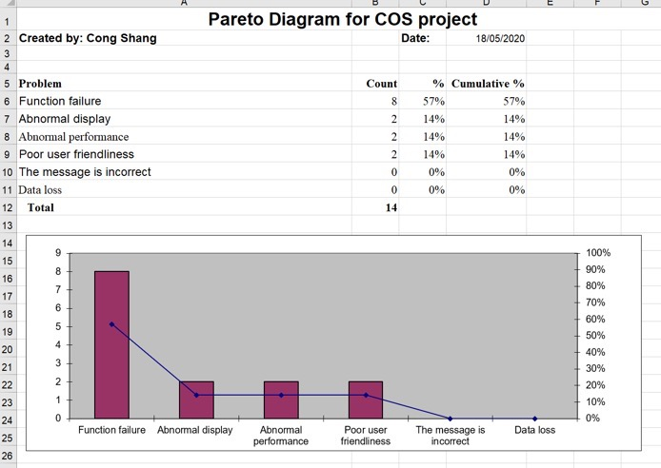

From the results of the first round of integrated test, we can see that the main problems focus on the operational functions, including system error caused by inconsistent data types, and the lack of required input field validation. After the bug was fixed, we performed a second validation. In the second validation, all the major issues were fixed except for one friendliness issue. After the discussion of the project team, it has reached the requirements of entering the system test.

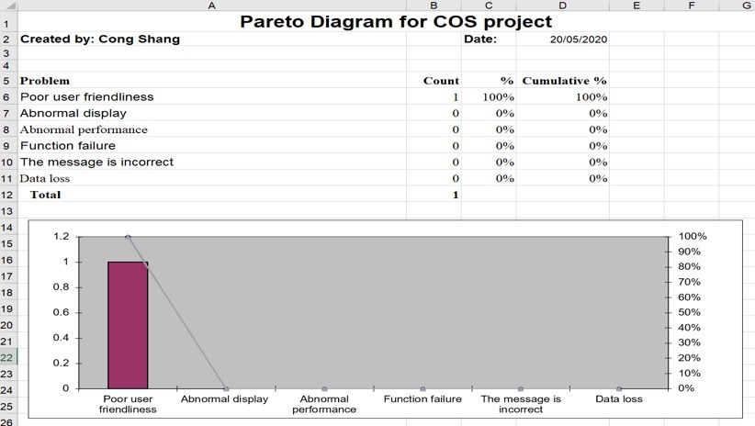

System Testing

【**Testing case statistics**】

|  |  |  |  |  |  |  |
| --- | --- | --- | --- | --- | --- | --- |
| Date | Total number of testing cases | The total number of cases found | Total number of cases resolved | Total number of cases with legacy issues | General Error rate (number of cases found/total number of cases) | Serious Error rate (number of cases found/total number of cases) |
| 17th May 2020 | 17 | 2 | 2 | 0 | 11% | 2% |

【**Issue category statistics**】

|  |  |  |  |  |  |  |  |  |
| --- | --- | --- | --- | --- | --- | --- | --- | --- |
| Requirement unfulfilled | Function failure | Data loss | Abnormal display | Abnormal performance | Poor user friendliness | The message is incorrect | The total number of issues | Number of remaining problems |
| 0 | 3 | 0 | 1 | 1 | 1 | 0 | 6 | 0 |

After these bugs were fixed, we performed a second validation. In the second validation, all issues were fixed.

User Acceptance Testing

【**Testing case statistics**】

|  |  |  |  |  |  |  |
| --- | --- | --- | --- | --- | --- | --- |
| Date | Total number of testing cases | The total number of cases found | Total number of cases resolved | Total number of cases with legacy issues | General Error rate (number of cases found/total number of cases) | Serious Error rate (number of cases found/total number of cases) |
| 22th May 2020 | 19 | 1 | 1 | 0 | 5% | 0% |

【**Issue category statistics**】

|  |  |  |  |  |  |  |  |  |
| --- | --- | --- | --- | --- | --- | --- | --- | --- |
| Requirement unfulfilled | Function failure | Data loss | Abnormal display | Abnormal performance | Poor user friendliness | The message is incorrect | The total number of issues | Number of remaining problems |
| 0 | 0 | 0 | 1 | 0 | 0 | 0 | 1 | 0 |

The project successfully completed all the testing steps and fixed all the defects and bugs found in the testing process. The project team made a statistical analysis of the data in the output test report for each stage of the test. There are no unmet requirements in the whole project test. Functional defects and interface friendliness have been fixed without affecting the delivery schedule of the project.

## Communication Management

There are three types of project meetings: team meeting, advisor meeting and client meeting. Team meeting is held once a week using the WeChat tool. It is mainly to confirm the work tasks , report the progress and discuss the temporary problems. Advisor meetings is held once a week through the Zoom tool. Mainly report the project progress of last week and the project schedule of next week, as well as the external business cooperation and problems, and discuss the solutions according to the relevant problems. Client meeting is held through the WeChat tool. It is mainly about the requirement discussion, requirement confirmation, function discussion and function confirmation, the client acceptance test and training, as well as the client handover.

The following figure shows the meeting statistics:

|  |  |  |  |
| --- | --- | --- | --- |
| Meeting Type | Communication Tool | Meeting Number | Frequency |
| Team meeting | WeChat, Email | 14 | 1/ week |
| Advisor meeting | Zoom, Email | 9 | 1/ week |
| Client meeting | WeChat, Email | 7 | 1/ two weeks |

## Risk Management

In the project planning stage, the project team carried out a risk analysis on the project, discussed the solution of risk events, and made a reasonable risk event plan. The plan reasonably avoids the risk events that may occur during the execution of the project. However, in the process of project execution, there are two significant risks, as shown below:

|  |  |  |  |
| --- | --- | --- | --- |
| No. | Grades | Risk Type | Description |
| 1 | High | External risk | COVID-19. The country implemented the isolation policy, and team members and the advisor could not meet, resulting in communication risks |
| 2 | High | Personnel risk | One member of the project team left the project team, and the project team lacked front-end developer |

Risk 1 result: due to the risk of communication with the advisor, the end dates of proposal milestone and system design milestone were delayed.

Risk 1 solution: the project team did not stop working because of the communication risks during the isolation. Although the end time of the milestone was delayed due to the delay of the evaluation time of relevant documents, the development and testing of the project have been progressing smoothly, so the progress of the milestone in the development and testing phase has not been affected.

Risk 2 result: due to communication and collaboration problems, a project member left the team three weeks after the project started. As a result, the project has no front-end developer.

Risk 2 solution: 1. Try to contact the person who has quit, and hope her to return to the team to avoid the occurrence of risks. 2. Find a new team member in order to control risk. 3. Communicate with the client and the advisor to reduce the impact of risks on the project by reducing the project scope. 4. Redistribute the responsibilities of team members and accept the impact of this risk.

From this, the project team realized the importance of project risk management. Clear plans should be made at different stages of risk identification, risk qualitative and quantitative analysis, risk monitoring and risk treatment, so as to maximize the risk control and reduce the overall impact on the project.

The project risk register is the primary tool for recording and tracking project risks. Maintain risk information continuously according to project execution. There are altogether 6 project risks registered in this project. The one that is still in the pending state is one. It is the impact of the epidemic on the project. This risk is still ongoing.

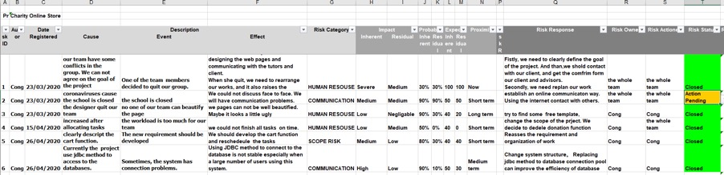

The main risks of this project are personnel risks, communication risks and technical risks. In the risk matrix, the high risk comes from personnel and communication, which is caused by the change of project members and the impact of the epidemic.

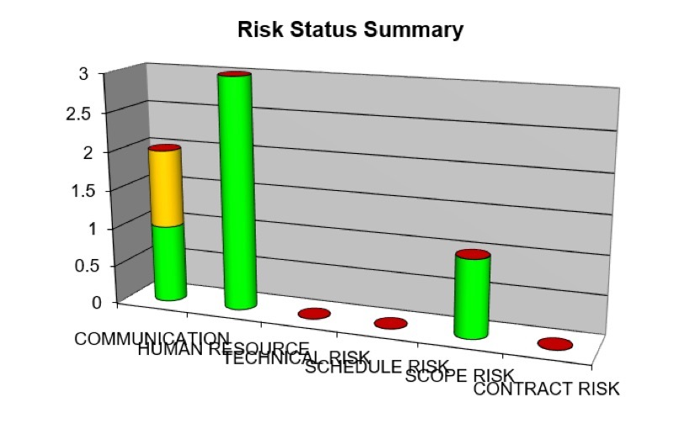

So far, five of the six risks on the project have been closed. One risk that is not closed is communication risk. Due to the isolation effects of COVID-19. The communication problems of the project team have been affecting the progress of the project.

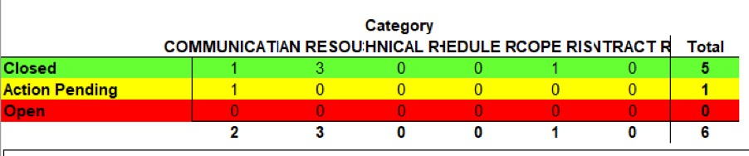

## Human Resource Management

Personnel introduction

There are two members in our team (Guozhi Yin, Cong Shang). Guozhi Yin is responsible for product design, project management, database, testing and documentation. Cong Shang is responsible for development, testing and documentation.

Zoe Liu is our client who works as an accountant at the Salvation Army second-hand store in Lower Hutt. She is responsible for project requirements discussion, validation, product function discussion, validation, and user acceptance testing of the product and some support to meet the go-live of the product.

Our advisor is Ian Hunter, who is responsible for monitoring the progress of the project, as well as giving team members advice and guidance on related tasks.

Personnel change

A team member left the project team after three weeks, posing a personnel risk to the project. Therefore, how to ensure that the project is completed on time brought great challenges to the project team. The member was in charge of front-end development, and after she left, the team members redefined project responsibilities.

Personnel contribution

Guozhi Yin spent 452 hours on the project and Cong Shang spent 467 hours on the project. Zoe Liu spent 30 hours on the project, and Ian Hunter spent 20 hours on the project.

|  |  |  |
| --- | --- | --- |
| **Name** | **Time** | **Involvement** |
| Zoe Liu | 37 hours | Client  Client meetings  User acceptance testing |
| Ian Hunter | 20 hours | Advisor  Advice and Recommendations  Project Meetings  Project Monitoring |
| Guozhi Yin | 452 hours | Project Manager  Database Administrator  Product Designer  Documentation  Testing |
| Cong Shang | 467 hours | Software Developer (Font End)  Software Developer (Back End)  Testing  Documentation |

## Data Management

All project documents were backed up to Google Drive and project code was backed up to GitHub. Because both have version control and can be restored to any previous version, project members can easily back up and share all project data.

## Resource Management

To complete the project, the project team prepared software and hardware resources. To reduce project costs in software resources, the project team tried to use free software (open source) as much as possible. For the hardware resources, the project team used their laptops.

# Lessons Learned

|  |  |
| --- | --- |
| Type | Description |
| Risk | In the project, we encountered two unidentified significant risks.  The first is the stability of the team. The project team did not effectively identify the risk before a team member left the project team. When the risk occurred, we did not have a plan to deal with it. We tried to communicate with the team member, hoping that she could return to the team to avoid the real occurrence of the risk. Another method is to find a new team member. But none of this has produced positive results. Eventually we have to take the risk.  Through this project, we learned the importance of personnel risk to the project. In future projects, the work of the core personnel should be backed up for role A and role B. Avoid the impact on the project caused by the leave of core personnel. At the same time, we should improve the personnel replacement plan, for example, when setting up the project team, we should list the candidates.  The second risk comes from communication. Because of the COVID-19, the team cannot communicate face to face. This brings great frustration to the project team, and the reduced communication efficiency leads to the reduced overall work efficiency. The solutions in this project include making full use of network technology and building a virtual team. Team communication, client communication and advisor communication are all completed online.  To change the project methodology, the original agile development methodology requires a large number of client participation, which needs to be deeply involved in the project activities at all stages of the project. Communication barriers forced us to change the prototyping methodology. The advantage of this methodology is that it allows a clear understanding of the project requirements during the project requirements phase. In the project implementation and test engineering, the demand is stable, which does not need a large number of client participation, and reduces the communication frequency. |
| Schedule management | In this Project, we used Microsoft Project as a progress management tool.  Based on the implementation process of the project, we defined five milestones for the project, and gradually refine the project.  The Project software provides a very convenient activity sorting function, which provides a variety of choices of dependencies. In this Project, the most commonly used one is as soon as possible  In the project, I encountered two schedule management problems.  1. In the early stage of the project, the project manager quit the project team, resulting in no one to take charge of these work. Our solution is to reassess the workload, redistribute the work, and re-plan the project schedule.  2. In the process of project execution, we realized the project schedule risk. If the adjustment is not made in time, the project may be delayed. Taking into account the time limit for the completion of this project, the measure we have taken is to reduce the scope of demand realization. Because development work is the primary task on the critical path, additional resources cannot be allocated to parallel tasks. |
| Team work | 1. Realising the importance of the project contract, the advisor asked the team to draft the project team contract at the initial stage of the project. In the contract, the Responsibility Assignment Matrix was listed.  2. In the process of team building, the role types of team members need to be appropriately matched. There is only one developer in the project, which leads to big pressure. In the future projects, the project team should be reasonably established according to the talent needs of the project.  3. Stability of project personnel. In this project, due to the leave of the front-end developer, front-end development work are under pressure. The project team is the most unstable stage in the early stage. In this stage, each member runs into each other, and there are the most contradictions. As we get to know each other, the team will come to a tacit understanding.  4. Team building is an important step to improve teamwork. Through team building, we can increase the tacit understanding among team members and understand their backgrounds and personalities. The construction of the team includes the dinner party of the project, organizing the project activities and so on. Due to the poor performance of this work in this project, major conflicts occurred at the initial stage of the project, leading to the leave of personnel. In addition, due to the COVID-19, it is impossible to organize group building activities, which will reduce the tacit understanding between team members. |
| Technology | Although the project members have many years of technical experience, some of the technical experience has fallen behind,  Project team in the technical selection of the project. A lot of time is wasted exploring the technical architecture and building the system architecture.  Here are two options:  1. Take advantage of the popular technology architecture on the market. Its advantage is security and stability, and more relevant information. The disadvantage is that there is a lack of professional technical personnel in the project. If new technologies are used, a lot of time needs to be wasted in learning and there are too many unpredictable technical risks.  2. Use familiar and stable technical solutions. The advantage is that it is easy to get started. The disadvantage is that it makes system maintenance more difficult.  In order to ensure the overall progress and quality of the project, the second scheme is selected. The lessons learned are to avoid project risks by prioritizing stable and familiar technical architectures that effectively reduce unpredictable technical risks. |

Through this project, the project team learned some experience in risk management, time management, teamwork and technology. These valuable experiences will be of great help to our future projects. Although the project members have many years of technical work experience and can quickly plan the objectives and responsibilities of each stage of the project. However, we still find that the time is not enough in the process of implementation. Through this project, we have mastered how to use the limited time to make a good project plan and delivery scope plan for the project. Moreover, we have improved our technical and documentation capabilities. In terms of document writing, after many reviews by the advisor, we also learned about the standards of language expression due to different cultures. Project members also learned the importance of teamwork. Although there were disagreements and quarrels when the project was at risk, we were still able to adjust our attitude and try to complete the project on time.

# Project Delivery

|  |
| --- |
| **Name** |
| Bid document |
| Proposal |
| Gantt chart |
| Project charter |
| System analysis and design document |
| Testing plan |
| Testing case |
| Integration testing report |
| System testing report |
| User acceptance testing report |
| User manual |
| User training |
| Installation and deployment document |
| Client receipt |
| Client acceptance |
| Meeting agenda and minutes with the advisor |
| Meeting agenda and minutes with the client |
| Meeting agenda and minutes with teammate |
| Requirement analysis document |
| System code |
| Project handbook |
| Project closure report |

# Closeout evaluation

|  |  |
| --- | --- |
| Project Name | Charity Second-hand Online Store |
| Project Acronym Name | CSO |
| Start Time | 2th March 2020 |
| End Time | 29th May 2020 |
| Team Member (Project Manager) | Guozhi Yin (Michael) |
| Team Member | Cong Shang |
| Advisor | Ian Hunter |
| Client | Zoe Liu |
| Project Phase | Initiation, Planning, Execution, Monitoring, Closure |
| Project Milestone | Proposal, System Design, Development, Testing, Client handover |

There are five phases in the project: proposal, system design, development, testing and closure. The project is in the phase of project closure now. The project team completed 5 milestones. Although the milestones in the phases of proposal and system design were affected by the external reason COVID-19 and changes in project team members, the scope and schedule plan were adjusted with the help of the advisor and coordination with the client. The project team successfully completed the development, testing and closure milestone in time.

At present, all materials of the project have been completed and archived. The project code is saved on GitHub, and all documentation are saved on Google drive.

Team member Guozhi Yin worked 452 hours and Cong Shang worked 467 hours, meeting the tutor's requirement. All Project materials will be evaluated as part of Project IT7501.

After testing by the project team and user acceptance testing by the client, the system meets all the requirements requested by the client. The project team has completed the client's training and the delivery of relevant documents, and received the client's receipt and the acceptance Email, so the project can be completed normally.

# Recommendations for future projects

Although this project team completed all the requirements requested by the client, the system only met the requirements of the first version. The project still has some requirements that have not been developed. The following is the details of the remaining project requirements and future planning improvements:

• Add donation function to support residents with donation needs to donate online and provide financial statistics.

• Add statistics function to support the statistics of customer dimension, order dimension, etc.

• Product picture supports multi-picture mode, and the main product picture can be set.

• Support users to choose a second-hand store by location.

• Develop APP, to facilitate the access of administrators and users.

• Support the inquiry and answer of commodity details

• Add email reminder function, it will support users to receive the reminder when auction prices change or auction times are due

• Strengthen the commercial promotion, connect more charity second-hand shops into the system, and serve more community in a wider range.